**ALGORITHM DESIGN AND ANALYSIS (SE- 303)**



**DELHI TECHNOLOGICAL UNIVERSITY(DTU)**

**REPORT**

**ON**

**TOPIC: STARTUP WEBSITE**

**SUBMITTED TO: SUBMITTED BY:**

**Mr. RAHUL GUPTA ANMOL YADAV (2K18/SE/028)   
 ASHISH KUMAR (2K18/SE/041)**

**ABSTRACT**

* This document provides a brief introduction to our project i.e. startup website. It goes through all the introductory information, explanation of different modules of the project, tools and technologies used, GitHub link of the implementation code and sources we used to complete this project.
* This document also addresses the advantages of having a website over not having one and why one should be focusing on the business’s online presence too.
* Different modules have been explained briefly and all the functionalities provided by the website have been mentioned.
* The website handles the interaction front of the startup, providing all the necessary details about the startup, provides contact information including emails, Twitter and Instagram profiles which are one click redirects, option to browse through other web development projects, and web developers who want to work with us can also approach us through the website itself.

**INTRODUCTION**

* As everything is digitalizing in this era, business also needs online handle, where everything is accessible on click of two fingers. Our aim is to provide people with websites, so that they could take their business online to expand their reach and accessibility.
* With this project, the interaction front of our startup is managed.
* The aim of this project is to develop a website for a startup company, to provide customers with good quality websites through which they can take their businesses online.
* Our website also provides an interactive experience where the user can browse through the services, look at our previous projects, websites we made and contact directly through email, if interested in taking business online with us.
* This website displays all the necessary information one would need whilst scrolling through the website, in an interactive way.
* This website provides direct contact options through email; one click redirects to social media profiles and displays ideology and motivation behind the startup.
* This website also has an about us page through which user can visit LinkedIn profiles of people behind this initiative.
* This website also allows the developers to apply for jobs in our company by entering their contact information and LinkedIn profile.

**PROBLEM DEFINITION AND SOLUTION**

* With the ongoing pandemic situation, people are looking for safer and effective methods to expand their businesses. Online business is more safer and reliable than offline considering the current Pandemic situation due to Covid-19.
* Not having an online presence can make clients not taking you seriously and you could end up losing them and even your business too.
* Considering that without a website, blog, or online presence prospective, clients could begin to wonder how serious you are about business. Today, all companies (small or big) and industries are establishing a successful online presence.
* Customer care centers can’t run round the clock on 24x7 basis as it would double their expenditure on services, whereas, online websites can solve the problems round the clock and answer any queries and generate leads (or sales), thus solving more clients queries and reduce the staff’s workload.
* Company doing online business will attract more and new set of customers.
* For new startups, directly doing online business terminates the need of a physical workspace, staff requirements, and operation costs to a great extent.
* The reach of online business is a lot more than offline counterpart. Hence, it is need of the modern era to have a website, which handles the netizens interests in your company
* Online businesses have many advantages over the offline counterparts. In addition to attracting more audience, having an online presence keeps businesses up to date with the rest of the world whilst handling many customers at the same time.
* With an online presence, you can give the customers just the information, they are looking for. This means fewer phone calls with technical questions resulting in more sales and profit. You can spend more time working on the revenue generating activities in your business and spend less time handling common customer service issues.

Having a website holds the following advantages over not having one:

1. Works 24x7 basis.
2. Attracts more audience.
3. Handles multiple customers at the same time.
4. 24x7 advertisements.
5. Accessible to more people.
6. More efficient, reliable and affordable.

and a lot more.

* We solve all these problems, provide functional websites which does everything mentioned above, and provide updates and bug fixes for the future as well. So, our clients need not to go to places as we provide one stop solution to all of their needs.

**TOOLS AND TECHNOLOGIES USED**

* Front End Technologies: html, CSS, Bootstrap, JavaScript
* Back End Technologies: PHP, SQL
* Versions of these technologies used: html5, CSS3, Bootstrap 4.0.0,   
   ECMAScript 5, PHP 7.4.11
* IDE: Sublime Text 3
* Website will be hosted on: http://localhost/phpmyadmin/
* Server: XAMPP server
* Server version: 10.4.14-MariaDB - mariadb.org binary distribution

**EXPLANATION OF DIFFERENT MODULES WITH SNAPSHOTS**

* This is Home page of our website
* Header provides clickable options for different pages of the website.

On the left side of header there is company logo and on the right there  
 is navigation bar.

* And then it has slideshow of 3 slides which changes with a set timer and also by the arrow head symbol (for better user experience), depicting company’s goals and motives. This slideshow is implemented by using carousel feature of bootstrap.

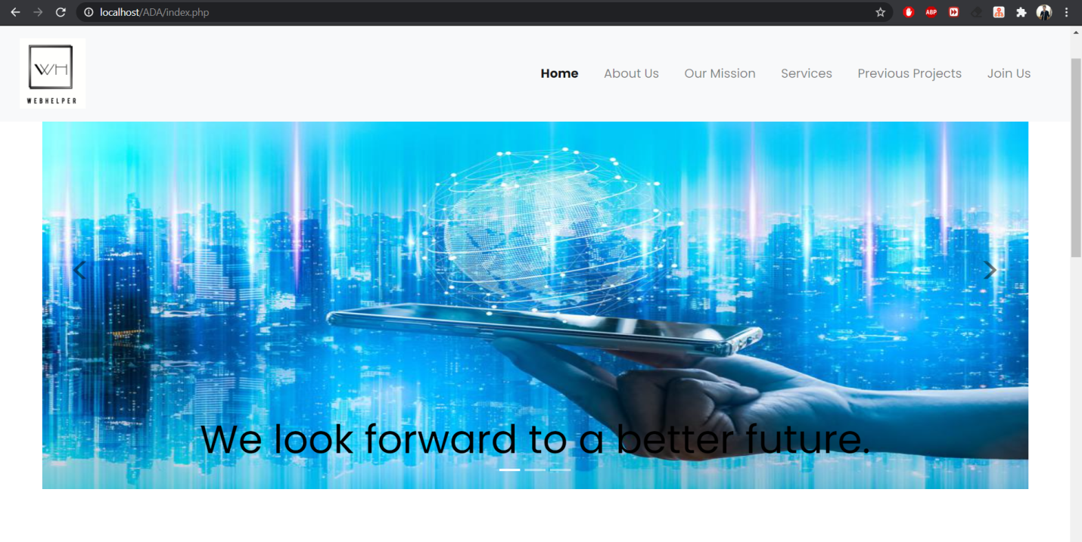

* Further down there is a tab, clicking on which displays a drop-down section containing a message about the idea behind this startup, and also a highlight of services we provide to our customers.
* Then there is option to connect with us on different social media platforms, namely Twitter, WhatsApp, and Instagram, as these are the most widely used social media platforms on the internet. On clicking on any of the 3 app icons, a redirect triggers which directly takes user to the profile’s feed or chat box of the respective web apps. We used these application’s API(s) to implement this feature.

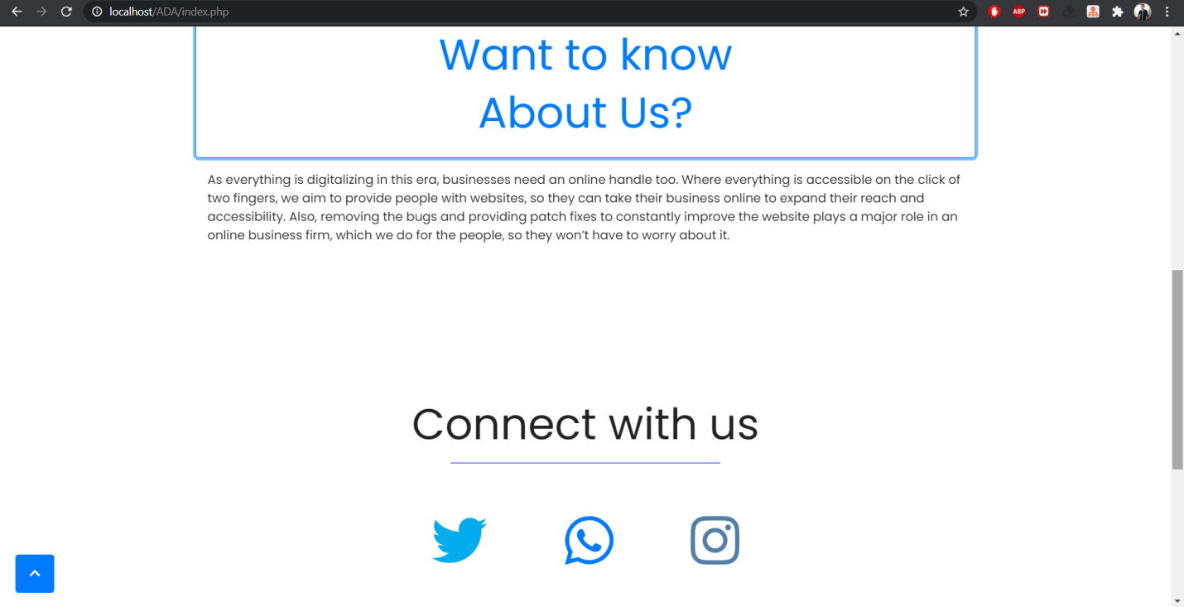

* Footer of the homepage has 3 fields, including postal address, email and phone numbers. Footer is implemented by using feature of bootstrap which helps to build footer of the webpage.
* Footer is same for all the pages in the website.
* On clicking on the email, it will redirect, and a new mail with a target address is created, without a body. Then user can mail us questioning anything regarding some sort of projects or quality products that we offered.
* On the bottom left corner there is an arrowhead facing up in all of the pages of the website. It is the scroll to top button which appears when the user has scrolled 100 pixels down from the top. It takes the user to the top of the page.

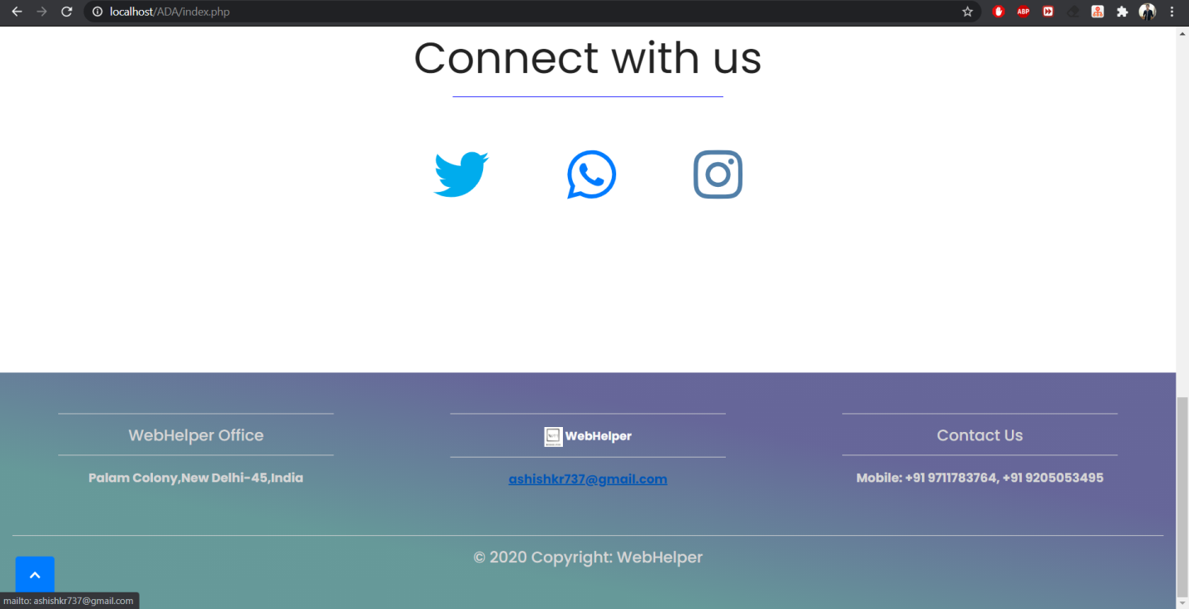

* This is About Us page of our website
* On clicking ‘About Us’ on the header of the website, a new page loads which consists the idea behind starting this company.
* There are 2 photographs of the persons behind this startup initiative, with name and post in the company.
* There is one button under each photograph, clicking on which, a redirect triggers which opens their personal profiles on LinkedIn, and Instagram respectively. We used these application’s API(s) to implement this feature.

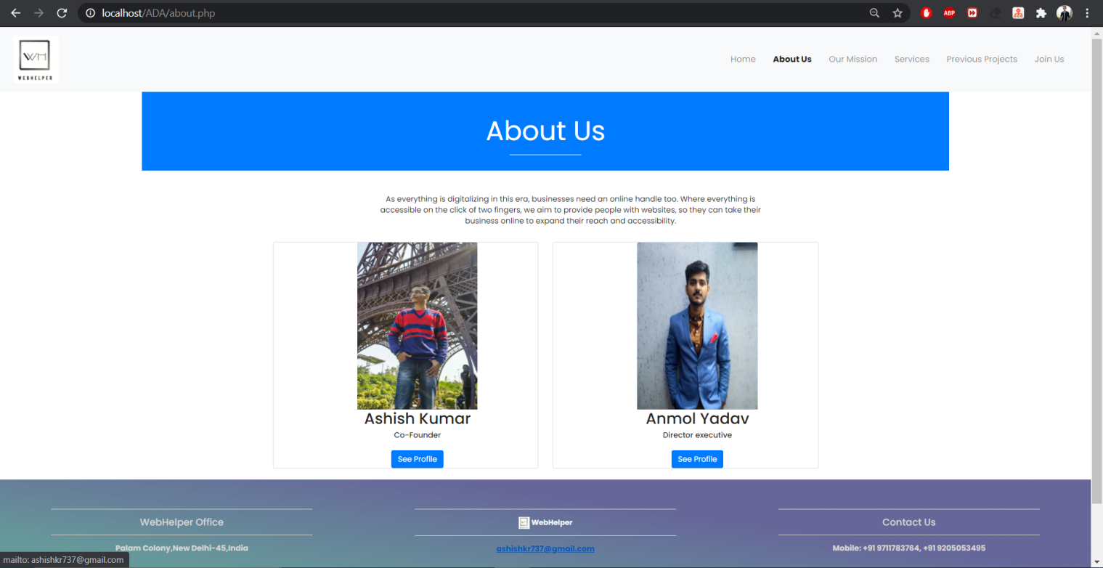

* This is Our mission page of our website
* A quote is displayed about websites in general.
* Then the aim of this startup is mentioned under ‘our mission’ heading, which highlights the basic idea behind our startup and our objectives of customer experience.

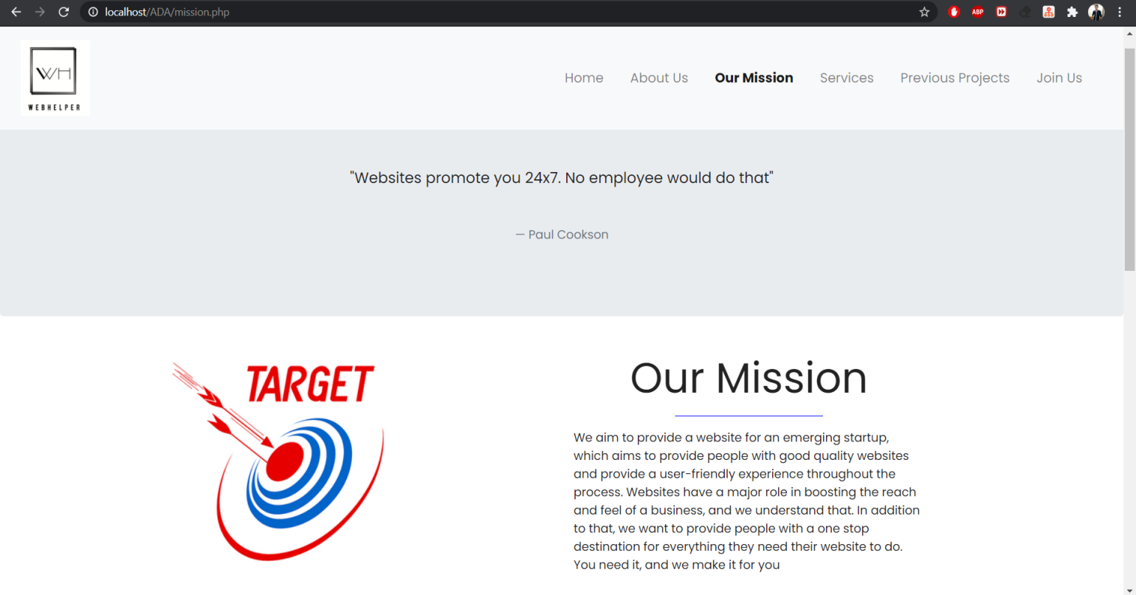

* Scrolling down we have mentioned 4 basic values behind our startup which are accountability, diligence, perseverance and integrity.
* WebHelper is a value driven company which guides the perspective of the organization as well as the actions.

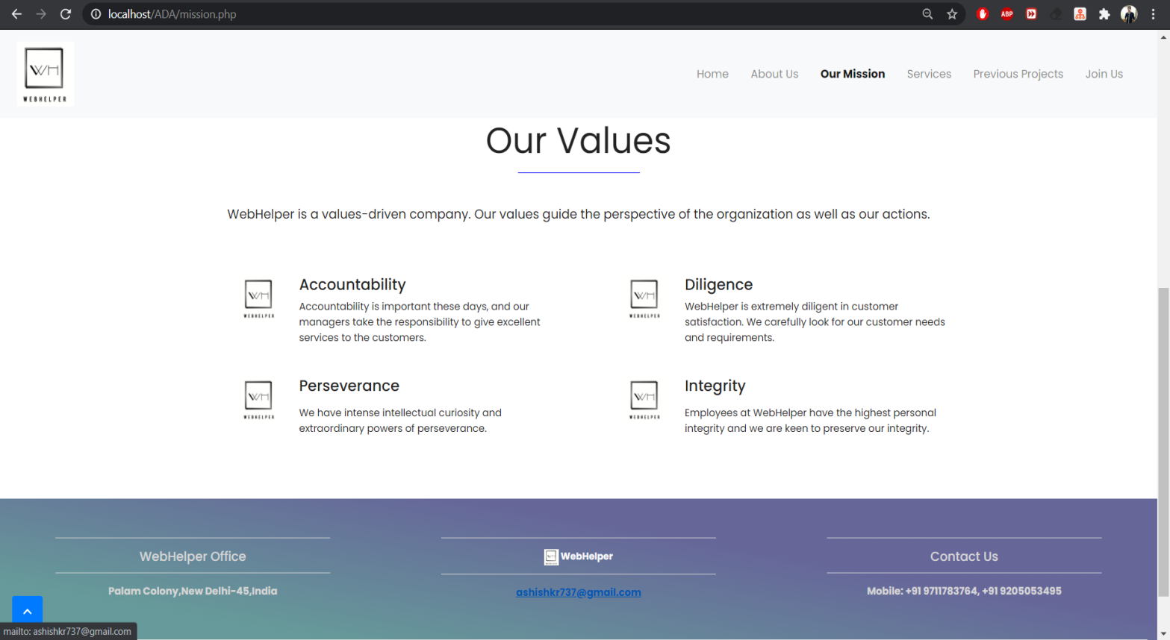

* This is Services page of our website
* On the top there is a quote from Laura Ashley.
* Then the services that we provide are mentioned under ‘our Services’ heading, which highlights what we do for the customers and how we make fully functional websites of any startup that customers are looking for.

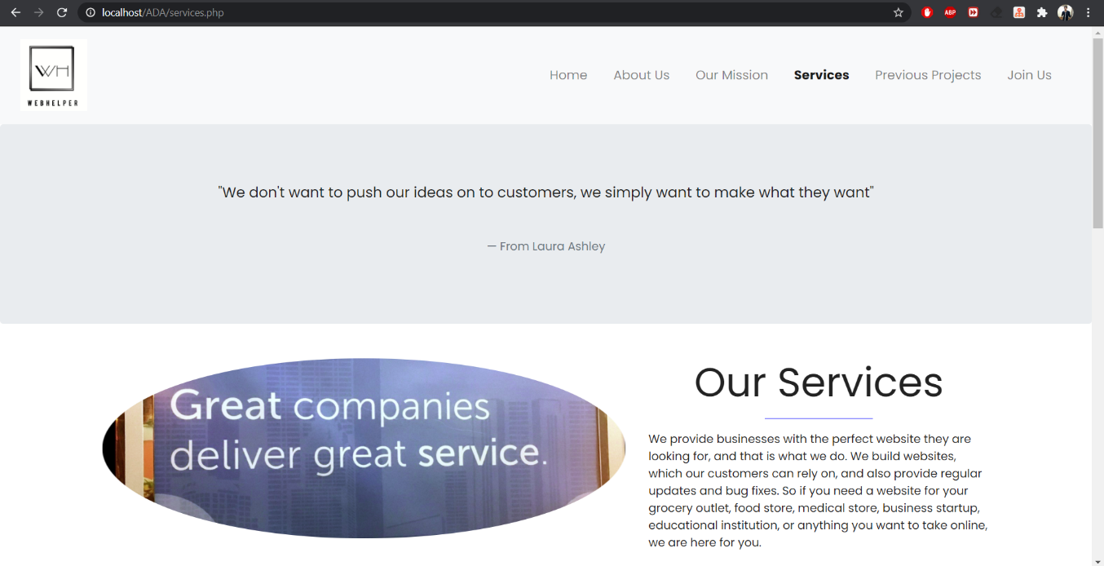

* Then on scrolling down, worth of products we provide is mentioned. We provide superior quality websites with costumer attractive ideas, fully functional, convenient to clients, easy to use.
* The site that we make for the clients is absolutely reliable in all the major aspects.

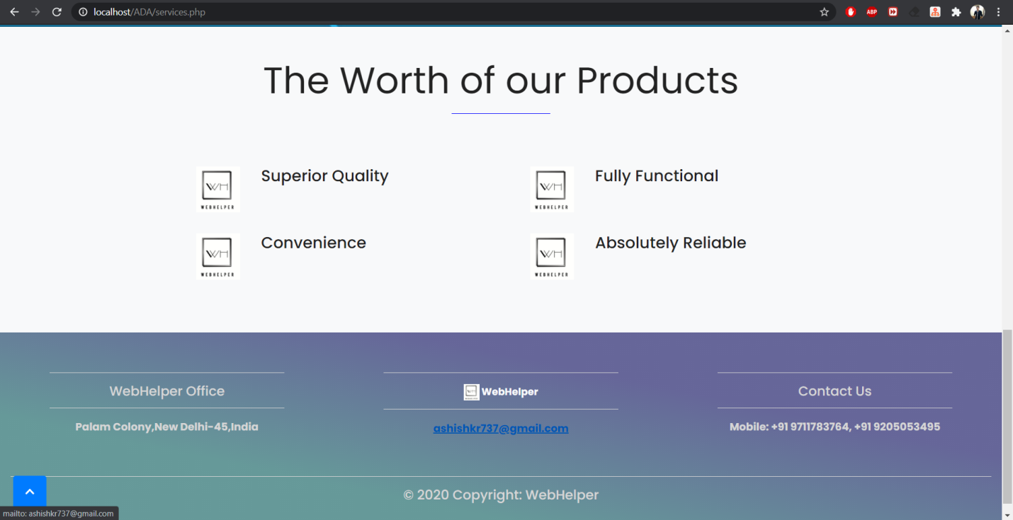

* This is Previous Project page of our website
* Clicking on previous projects option in the header redirects to github page where our previous projects are listed. User can browse through them and have a look at them.

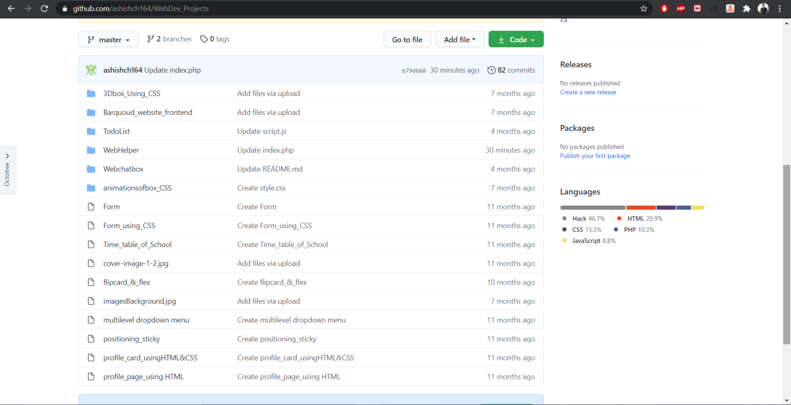

* This is Join Us page of our website
* Join us page is for the developers interested in working with our startup and for the users also who wants to make website for their company from us.
* A tab appears labeled as ‘wish to step forward with us’; clicking on which, a form appears.
* There are 5 fields to be entered by the user.
* Every field has validity checks.
* No field can be left empty or of invalid format.
* Submitting the form stores the entered data in the database, which is accessible to us. From there we can contact the person who submitted the form.

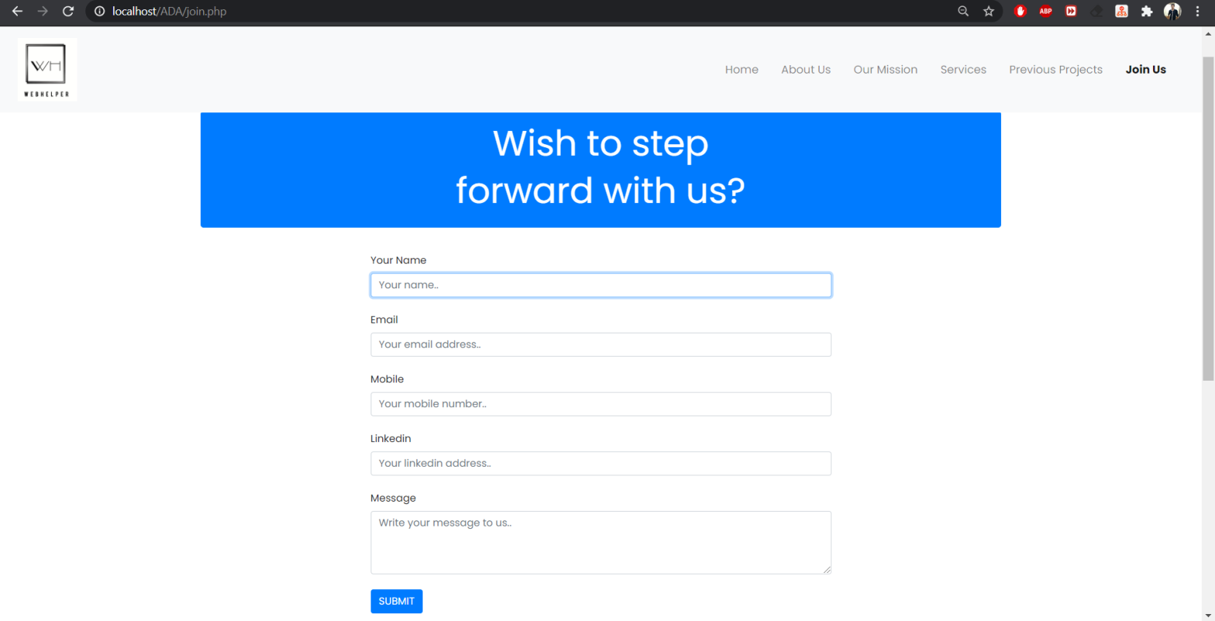

**IMPLEMENTATION CODE**

* Github link: https://github.com/ashishch164/WebDev_Projects/tree/master/WebHelper

**BIBLIOGRAPHY**

1. https://medium.com/@solodev/add-a-scroll-to-top-button-to-your-website-ece1ed82d72e

2. https://getbootstrap.com/docs/4.5/components/carousel/

3. https://getbootstrap.com/docs/4.5/components/navbar/

4. https://getbootstrap.com/docs/4.5/components/forms/

5. https://mdbootstrap.com/docs/jquery/navigation/footer/